Student’s Name
Subject
Date
SPH3U Unit D Test

1. Draw the fundamental frequency of a spring which is stretched between two rigid ends. Then, draw the second and third harmonic overtones for the same string. [4K]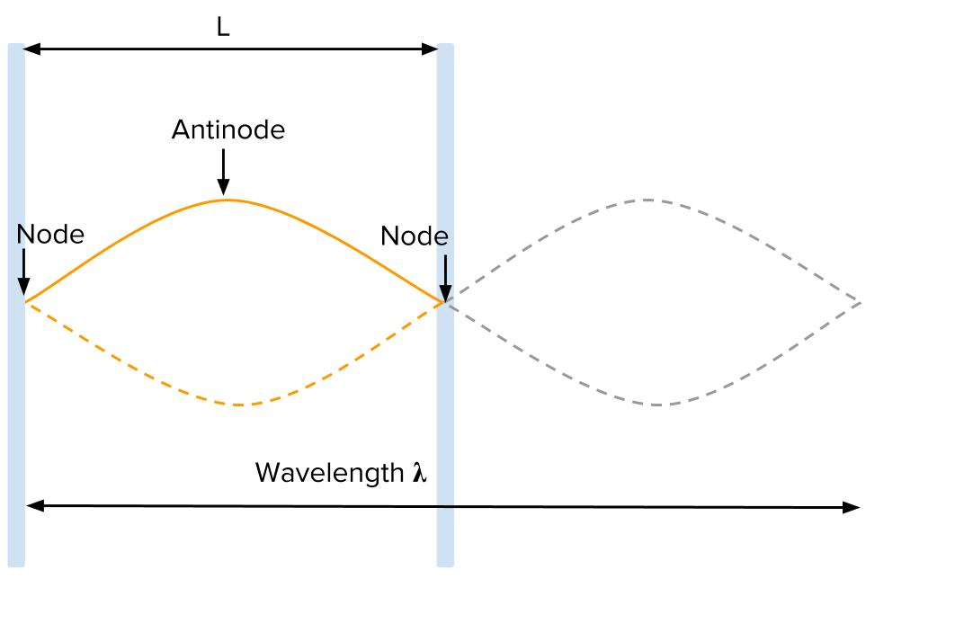

Second harmonic overtone
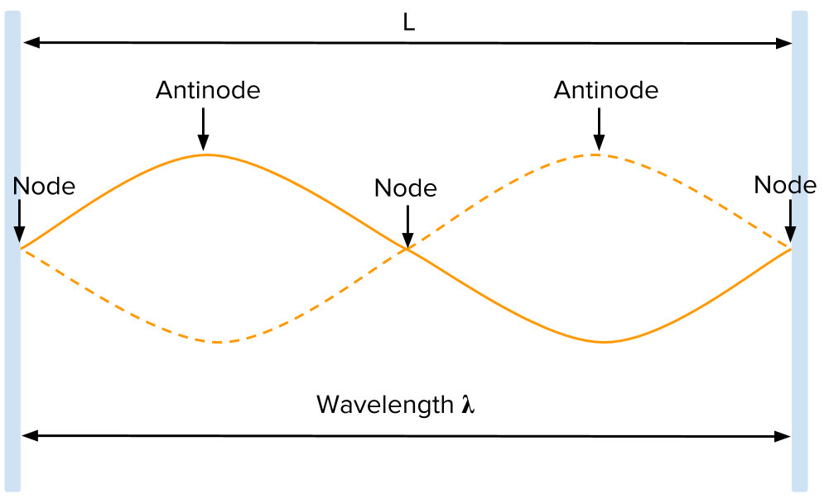
Third harmonic overtone
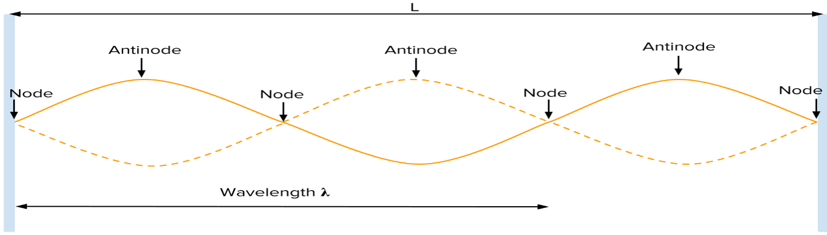
2. 2). What do waves transport? [1K]
Waves transfer or transport energy over distances.
3) A longitudinal wave consists of _alternating compressions and rarefactions in a medium [2K]
4) When using the decibel scale, every 3-DB increase in sound intensity level is a double in intensity. A 10-DB increase increases the intensity by 10 times. [2K]
5) What is the wavelength of a wave vibrating with the fundamental frequency in a string that is stretched between two fixed points, 2.50 m apart? [2K]
Wavelength is simply distance between two troughs or successive crests of a wave.
Wavelength. λ = v/f
In this case, wavelength is 2.50m
6) What is the speed of sound in air, at – 20.0 °C? [1K
The sound speed in air is approximately 343 meters per second.
7) Rank these materials in which sound may travel from fastest to slowest: [4K]
a) Aluminum
b) Water
c) Steel
d) Air
Aluminum- Steel- water- Air.
8. A) what is the period of a wave that has a frequency of 55 Hz? [2A]
T= 1/f
1/55= 0.0181818
= 0.018 seconds.

b) What is the frequency of a wave that has a period of 5.0 s? [2A]
T= 1/f
Now, F= 1/T
= 1/5.0
= 0.2Hz
9) If one singing bird produces a sound intensity level of 75 decibels, what sound intensity level will two singing birds produce? [2A
In this case we will first convert db to w/m2
One decibel (0.1 bel) equals 10 times the common logarithm of the power ratio.
Sound intensity of one bird = 3*10⁻⁵
So the sound intensity of two birds =
= 10 (log2+log1/I
= 10 log 2+10log1/i
10-2+b
8+75
83db

10) A tuning fork with a frequency of 256 Hz is held above a closed air column while the column is gradually increased in length. At what lengths for this air column would the first four resonant points be found, if the speed of sound is 330 m/s? [6A]
Ln = nv/4v= {330n/(4*256)}
=0.322265m
L1=32.23cm
L2= 64.46cm
L3=32.23*3= 96.69cm
L4= 128.92cm

11) An airplane is approaching at a speed of 360 km/h. If you measure the pitch of its approaching engines to be 512 Hz, what must be the actual frequency of the sound of the engines? The speed of sound in air is 345 m/s. [4T]
To find the observed frequency, fobs=fs (vw/(vw±vs)) fobs=fs(vwvw±vs) must be used because the source is moving. The minus sign is used for the approaching train, and the plus sign for the receding train.
We have to convert 360km/hr to m/s= 100m/sec
F obs= (512Hz) {(345m/s)/ (345m/s+100m/s)}
= 396.93Hz
12) A police car siren has a frequency of 850 Hz. If you hear this siren to have a frequency that is 40.0 Hz greater than its true frequency, what is the speed of the car? [4
In this case we assume sound speed in air to be 343m/s
And speed of car to be X
F obs= 850Hz {(343m/s/ (343m/s+x)}
890Hz (343m/s+X) = 850*(343m/s)
= 305, 270+ 890X= 291550
X= 13720/890
= 15.42m/s
13) In your own words, explain what a shock wave is, and give an example of when one may occur. [3
A Shock wave is simply a strong pressure wave produced by elastic medium like a solid, water or even air. A shock wave can occur due to chemical or nuclear explosions, with the sonic boom of supersonic aircraft and so on.
14) Explain, in your own words, why sound tends to travel at faster speeds in cold air as compared to warmer air. [3C]
Sound travels at faster speed in cold air than warmer air because sound waves tend to bend away from the warmer air and then back towards the ground. In other words, the sound waves moves from hot air to cold air. Also this implies that sound waves from cold air to warm air will be refracted.

